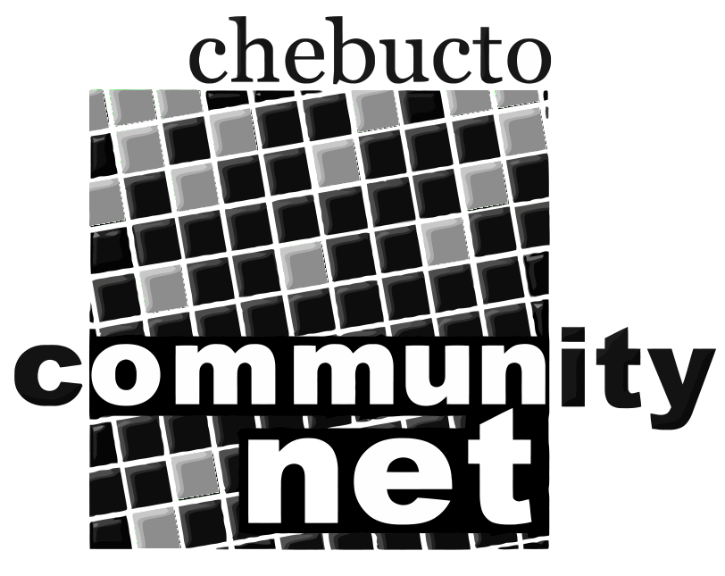 | Chebucto Community Net  Annual General Meeting  April 22, 2015
Technical Report
CCN Makeover Project
The Makeover Project is an effort by volunteers to update some of the systems at CCN. New hardware has been purchased to replace the older systems, some of which are over 15 years old. Work is being done to improve the back-end and accounting system we use to manage membership accounts and services, but we also have improvements planned for member services, such as email, website and database hosting, dial-up and wireless Internet access, and also an updated webmail interface.
The CCN Makeover Project is lead by Corrie Watt, with the support of Chris Watt, Chris Maxwell. Ed Dyer, Joey Mingrone, John Thibodeau, Reg Hody, and Shahab Rowshan.
Manors Project
Following on the success of the high-speed wireless installation at Joseph Howe and H.P. MacKeen manors, the Manors Project is moving forward with work being done to expand coverage to three additional manors in the North end of Halifax.
With the help of a grant from the CIRA Community Investment Program, Ahern Manor, Sunrise Manor, and Gordon B. Isnor Manor are being fitted with wireless access points, capable of delivering our high-speed wireless service to the residents within. Originally slated to be online in late 2014, work has been delayed while we await approval from Dalhousie University to mount additional wireless bridges on the roof of the Tupper Building.
The Manors Project is championed by CCN Office Manager Andrew Wright, and volunteer wireless expert Dave Johnston.
Other News
Much of the day-to-day technical work at CCN has been on maintaining the status quo while our efforts are focused primarily on the CCN Makeover and Manors Projects. This past winter saw a few service disruptions from power outages, both planned and unplanned. Spam email continues to be an issue, with more viruses being sent by email which is increasing the demand on our current mail scanning servers.

John Thibodeau
Technical Director
Chebucto Community Net

