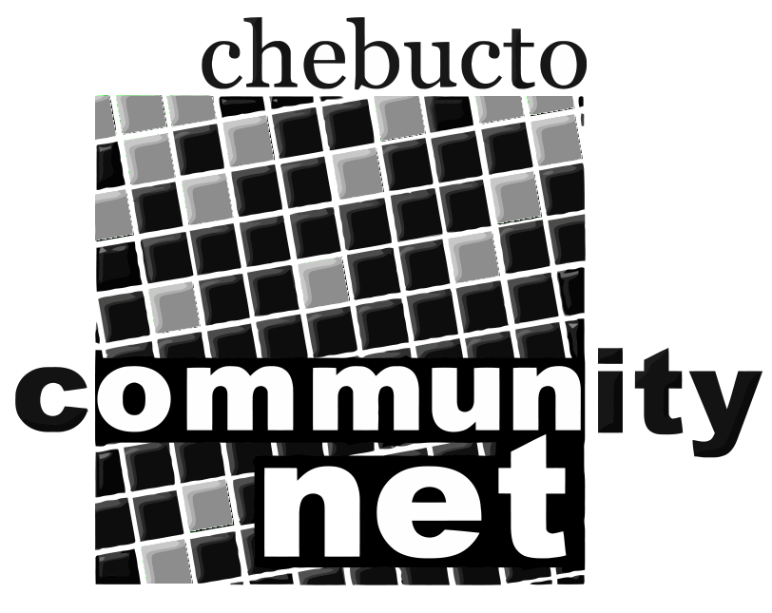 | Chebucto Community Net  Annual General Meeting  April 22, 2015
Policy Committee Report
The role of the Policy Committee is two-fold:
- to address policy development and implementation issues; and
- to address complaints or abuses about and by CCN members.
2014 was a quiet year for the Policy Committee.
Two users had their passwords compromised. Spammers immediately sent out thousands of junk emails from each hijacked Chebucto email account. In both cases we caught the abuse within a few hours.
For one user this was the second time being fooled by scammers to reveal their password so their membership and account were terminated.
Newer password gathering schemes use infected files either emailed to or downloaded by the user, frequently exploiting vulnerabilities in older unpatched software to install key-logging software to capture passwords and other personal information.
We cannot stress enough the need for only using updated Operating Systems and programs, and making sure they are kept safe with good security software including anti-virus and anti-malware protection.
With our last two years of experience operating highspeed Internet access as a guide there needs to be discussion about what we allow and don't allow on the network. For one example our upstream provider Dalhousie University doesn't allow any Windows XP computers on its own network for network security reasons but we still provisionally do on ours. For another, should we limit the number of user devices that can access our network at the same time or register them as a method to counter account access fraud? We've had one case already of someone using another's access, detected manually and stopped with a warning but as user numbers grow this will become more of an issue.
As in previous years we are looking for people interested in serving on the Policy Committee. Interested parties can submit their names to office@chebucto.ns.ca.
Andrew D. Wright
Chair, Policy Committee
Chebucto Community Net Society

