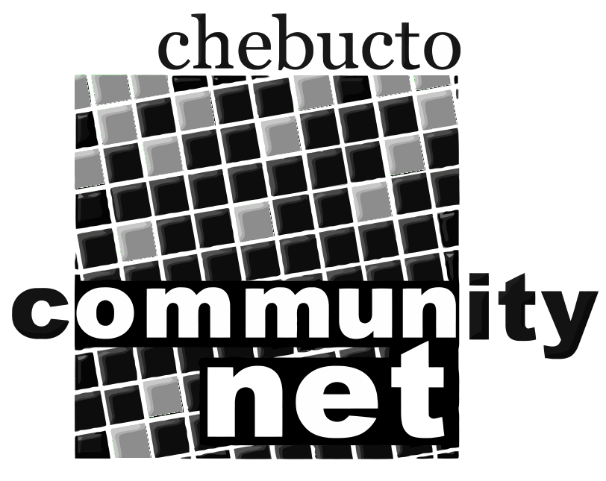 | Chebucto Community Net  Annual General Meeting  April 23, 2014
Report from the Chair of the
Board of Directors
If you had to describe the dominant item of business for Chebucto last year in two words, those words would be "Manors Project." Bringing wireless Internet connections to Joseph Howe and MacKeen Manors was a major undertaking, from the installation of the access points, through fine tuning the system to information and training sessions for our users, not to mention house calls. No one was more strongly tested and strenuously tasked in this process than our office manager and he most certainly deserves our very grateful thanks.

Some external media did notice our success: CBC Radio programs ran features, as did one private television and one private radio show. The Chronicle Herald also made us the cover story in one of its community editions. Online publications also carried stories on our venture and its successful completion.

But it was on our Twitter feed that most of the news went out and was commented on. Twitter continues to develop and attract steadily increasing numbers of followers, particularly, it seems, among media types and politicians from all levels of government.

During last year's provincial election campaign we were very pleased--and somewhat surprised--when all three of the candidates from the major political parties in the Halifax Citadel/Sable Island seat contacted us and asked to meet and find out more about Chebucto. The Executive met with one candidate and Andrew, Johnathan and I met with the other two. The meetings went well; none of them really knew much about us and all were impressed with the work we're doing. One of them even gave us a personal donation.

We were active on the municipal front too. In July we participated in an event hosted by District 7 Councillor Waye Mason in which various community groups made their cases for receiving funds from the capital grants program. Someone described it as a cross between a high school science fair and Dragons' Den. Anyway, several of us made our pitch for Chebucto and those who attended then voted on the successful groups. We weren't the biggest winner, but we did come away with $6,250 which we'll certainly be putting to good use.

Also on the municipal side we've been active in trying to ensure that Chebucto has a voice in the ongoing discussions concerning the installation of municipal wireless. Andrew has met with Mayor Mike Savage's principal assistant and has been in touch with the group from Dartmouth, as well.

In short, we have started into our 20th year of existence in better shape than we have experienced in some time. But there are still problems to which we must find solutions: we've shown modest but definite success in attracting new members and donations but we must do much better at both. We've spread the word more widely about who we are and what we do but we still need to make Chebucto much better known. As members, you have a role to play. Experience has shown us that most people learn about Chebucto through word of mouth. Getting that word out is crucially important to us since we lack the financial resources to be able to do advertising and promotional campaigns. So please do get out there and spread the word among those in your communities. It will help
a lot.

In closing, I do want to thank my colleagues on the Board of Directors. We've had a busy but productive year. And I have experienced great pleasure in working with staff and my follow Chebucto volunteers. So, a happy 20th birthday to us all. I hope there will be many more years to come in which we may be of service to our community. We will continue to support and work for the provision of affordable access to the tools of technology for all.

Marilyn MacDonald
Chair
Board of Directors
Chebucto Community Net Society

