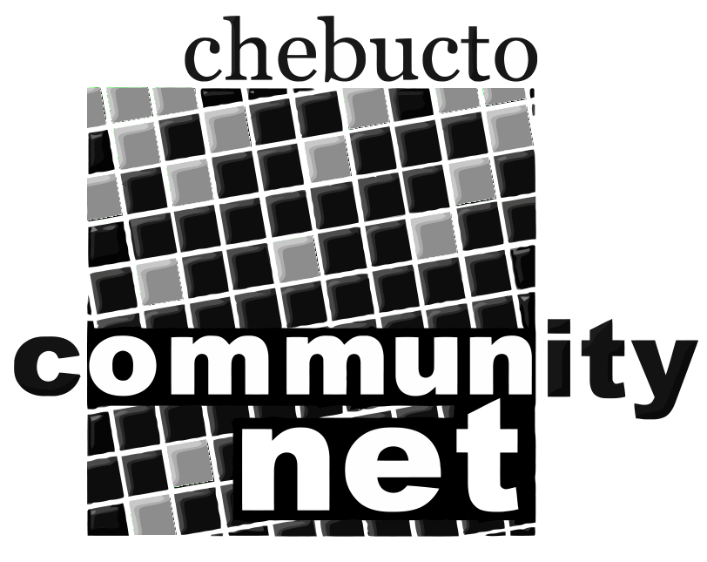 | Chebucto Community Net  Annual General Meeting  April 17, 2013
Policy Committee Report
The role of the Policy Committee is two-fold:
- to address policy development and implementation issues; and
- to address complaints or abuses about and by CCN members.
2012 was a fairly quiet year for the Policy Committee.
In 2012 just as in 2010 and 2011, we had two cases where user passwords were compromised. Spammers immediately sent out thousands of junk emails from each of the hijacked Chebucto email accounts. In both cases we caught the abuses within a short time. The users claimed not to have voluntarily given out their passwords to third parties either through responding to an email or filling in a non-Chebucto website form.
We cannot stress enough that all users need to have good up-to-date anti-virus and anti-malware detection and keep their Operating Systems and programs updated.
We also had two incidents of website hijacking. Both were from organizational websites where a third party had installed software for the organization which was then never security updated. Over time the software became vulnerable to exploitation. In one case we set up a Chebucto version of the software set to automatically security update, the other is being monitored closely by the site owner while a more permanent fix is implemented.
Chebucto users are still reporting receiving phishing phone calls claiming to be Microsoft, Windows, and Dell Computer. These are typically East Indian criminals using cheap low quality Voice over IP phone connections to try to trick the user into letting the criminals gain remote access to their computer.
As in previous years we are looking for people interested in serving on the Policy Committee. Interested parties can submit their names to office@chebucto.ns.ca.

Andrew D. Wright
Chair, Policy Committee
Chebucto Community Net Society

