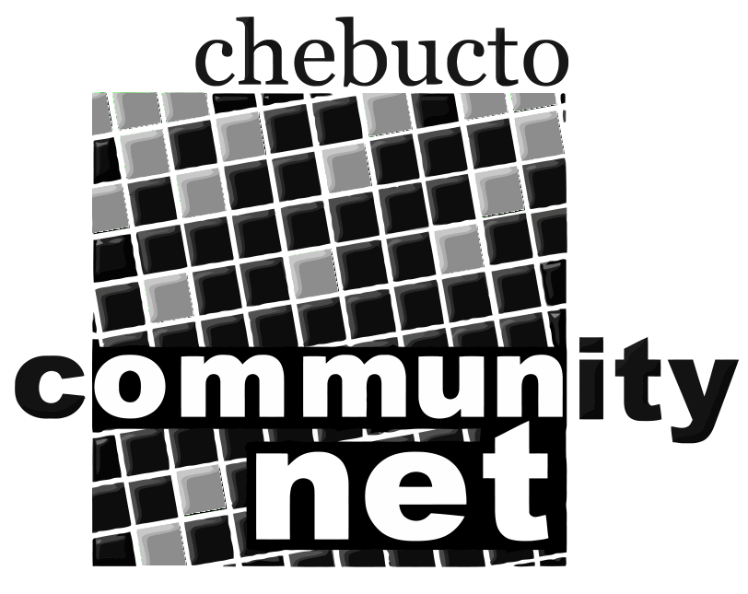 | Chebucto Community Net  Annual General Meeting  April 17, 2013
Agenda

1. Presentation on the Manors Project by Andrew Wright.

2. Call to order

3. Minutes of the 2012 Annual General Meeting

4. Report from the Chair

5. Treasurer's Report

6. Report from Policy Committee

7. Technical Report

8. Election of Directors

9. Appointment of Auditor

10. Other business

11. Awarding of Door Prizes to winning members in attendance.

12. Adjournment

All are welcome to attend this meeting. However, only members in good
standing are eligible to vote on the motions presented or be nominated
for office. Proxy voting is not allowed.

