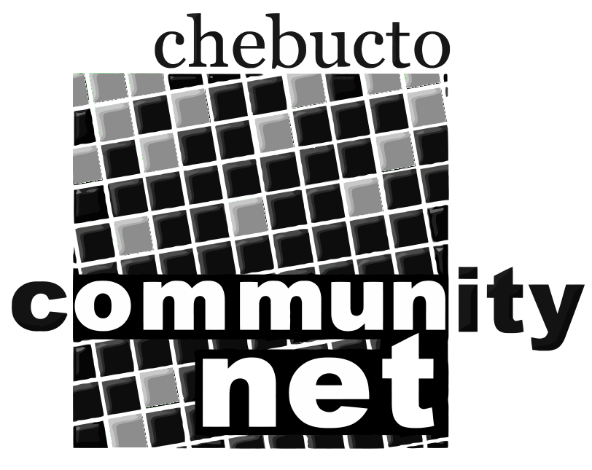 | Chebucto Community Net  Annual General Meeting  April 25, 2012
Report from the Chair of the Board of Directors

In 2011 the Board met a total of 12 times, once each month. The
Executive Committee, which consisted of Alan Turner, Board Chair and
Treasurer; Marilyn MacDonald, Co-Treasurer; and Deborah Dostal, Secretary,
met 9 times. I take this opportunity to thank all the Board members, all
of whom are volunteers, for their contributions to our operation in 2011.
As reported more fully in my report as Treasurer we have a lot to thank
Andrew and Johnathan for, also. But for their generosity we could not
have continued in operation. Andrew, whose job title is Office Manager, but
who is, in fact, a general factotum, is working more than full time but
drawing only half salary. Johnathan, who used to be our employee
technician, now works full time for Dalhousie University but still
manages to take care of our technical needs.
This places huge demands on his personal time and inevitably emergencies arise when Johnathan is tending to his university duties and not available to us. Andrew has come to the fore and has been learning to handle some technical needs
and take care of these emergencies. I think you will agree that we have
not seen a drop in our level of service. In addition another hero has
come forward. Ed Dyer, who used to be our Technical Director a few years
ago, has re-joined the Board and he, Andrew, and Johnathan have begun
meeting regularly so that we may not only maintain but also upgrade our
services. They are also looking into attracting more tech-savvy
volunteers to help with this process, so if you are, or know of, such a
person, please let us know.
We have also increased our role as spokespersons and advocates for
affordable Internet access, which is, after all, our mission. You will
all be aware of the federal government's action of cutting off funding
to the CAP program. We have made representations federally,
provincially, and municipally in favour of continuing the program. We
have no success to report yet in this instance, but we plan to actively
pursue the role of advocacy in the future.
I have to update the status of our efforts with wifi. In brief the
status is "inactive". We do not have the human or financial resources at
the moment to pursue this. We do hope to pick it up again in the future,
and we hear frequently from folks at Joseph Howe Manor which was to be
our pilot location. They are still interested, as are we.
You have heard in past AGM's that we know there is a need for what we
offer, but we don't have the resources to spread the word to reach those
who need us. You have also heard, in Andrew's presentation, that the
social media are giving us exposure that we never had before, and we
hope that will continue to expand. Our thanks to Andrew again, for this
is almost entirely his "baby". I do encourage all our members to
participate and help spread the word. The more we are known, the sooner
we may grow back to a solid position with a secure future.
Thank you, Alan Turner

