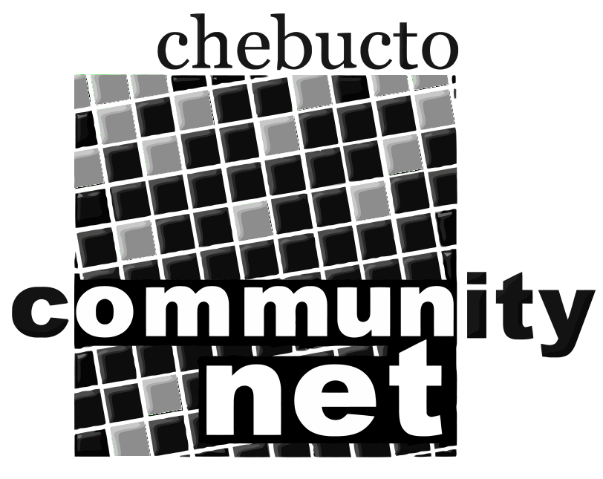 | Chebucto Community Net  Annual General Meeting  April 27, 2011
Treasurer's Report
The figures on the financial statement of revenues and expenditures (in your package) while obviously correct, since they were prepared by our accountants, are somewhat misleading. Of the figure under grants (in revenue) $21000 was received by us years ago but the accountants considered it prudent to hold it as deferred income since they felt there might be a possibility that we would have to pay it back. They now think this possibility sufficiently negligible that they can confidently take it into income. They have also made their usual year-end adjustments, but as the person watching over the cash on a daily basis I can tell you that at year's end we had taken in approximately $10000 more than we spent, even though the total revenue was almost ten per cent less than that of the previous year.
We did a good job of controlling expenses, which were twenty-six per cent less than the year before. We kept them to the minimum possible without affecting our ability to operate, but two factors enabled us to end up "in the black". One was that Andrew, now our only employee, donated half his hours throughout the year. Had he not done so our salary costs would have been $15000 higher. We can all do the math: without his generosity we would have been $5000 "in the red". The other factor was that Johnathan is now a Board member instead of an employee but still maintains all our equipment and systems - a considerable task requiring presence at all hours - on a volunteer basis. We all owe Andrew and Johnathan a huge vote of thanks. Without their efforts we couldn't operate.
Since we started this year (2011) with a sufficient cash balance we have insisted on restoring Andrew to full salary, though he has indicated his willingness to revert to reduced salary if it means the survival of the Society.
Perhaps here I should remind members that we are a registered charity and can give tax-reducing receipts for donations. Many of our members remain with us through loyalty and belief in our mission to provide affordable internet access. Donations will also help the same purpose, though you can see that these declined by almost fifty per cent in 2010. This is an area where, with a little effort, our members can help a great deal. Tell your friends and acquaintances what a good purpose they will be supporting with their donation to us.

