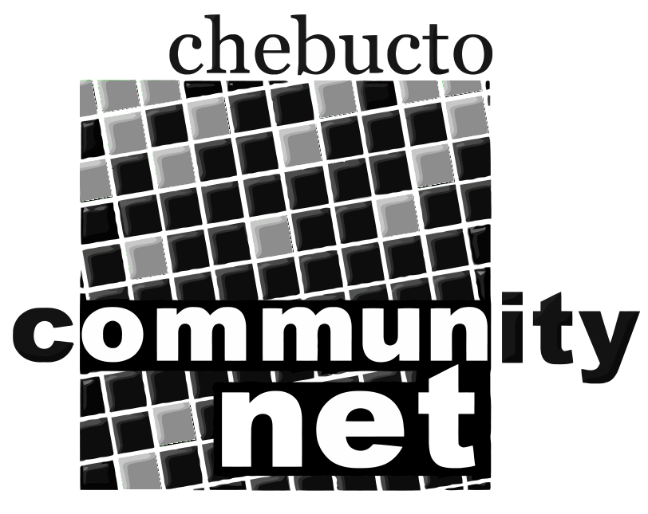 | Chebucto Community Net  Annual General Meeting  April 27, 2011
Policy Committee Report
The role of the Policy Committee is two-fold:
- to address policy development and implementation issues; and
- to address complaints or abuses about and by CCN members.
2010 was a fairly quiet year for the Policy Committee.
As in 2009, the biggest abuse of Chebucto services came from Nigerian criminals convincing Chebucto users to send them their email passwords. Despite warning letters to our users alerting them to the danger, and a constant warning on our Message of the Day and home page, in the past year two Chebucto users sent the criminals their passwords.
In both cases we disabled the user accounts within twelve hours, as soon as we were aware of the breach, but by then the damage had already been done. Each user's account had sent out hundreds of thousands of spam emails to accounts all over the world with the user's name prominent on each and every one. In each case the aftermath lasted several weeks, with Chebucto showing up on mail block lists and the office receiving hundreds of spam reports.
We cannot stress strongly enough that you should never, ever send your password in an email to anyone, ever, no matter what they say. We will also never direct you to a non-Chebucto website asking you for your password. It is no small source of frustration to tell people that over and over again and have them turn around and ask if this email asking them for their password is legitimate.
Phishing scams, as these are called, and spear-phishing scams, where a serious attempt is made to impersonate the system administrators, are a growing threat to all mail systems everywhere. Chebucto, as a smaller provider, is particularly vulnerable to the aftermath of such scams.
As in previous years we are looking for people interested in serving on the Policy Committee. Interested parties can submit their names to office@chebucto.ns.ca.

Andrew D. Wright

