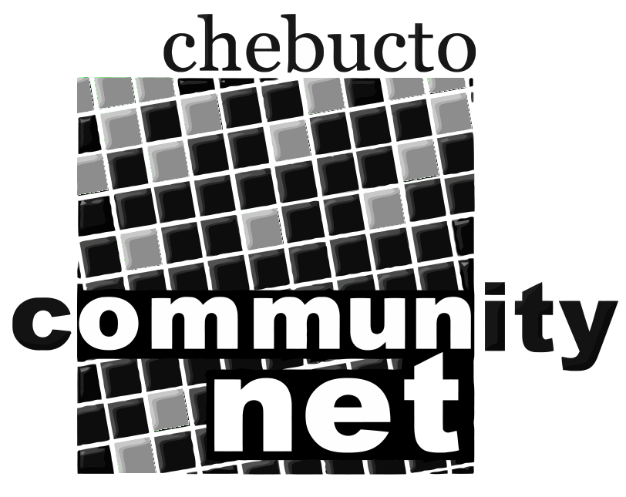 | Chebucto Community Net  Annual General Meeting  April 29, 2010
Report from the Chair of the Board of Directors
Chebucto's fifteenth anniversary year was a time of looking back as well as ahead - looking back to our origin and our initial mission and ahead to the changes in service we are hoping to institute.
We also attempted to make ourselves better known to the present crop of municipal and provincial politicians. We met with MLAs Graham Steele and Leonard Preyra and received a warm reception.
At the Municipal Level we communicated with Councillors Sloane and Uteck.
In addition we made a presentation to Halifax City Council outlining our role and our need for support. I would like to pay particular thanks to Vice Chair Marilyn MacDonald who prepared and delivered the presentation to the Council. In her talk Marilyn stressed the point that the need for a community owned, low cost service is as great as ever; and further, our Community, relative to others in Canada, is falling back in terms of Internet access and usage.
I also want take this opportunity to thank our two staff members Andrew Wright and Johnathan Thibodeau who give so much for so little. As some of you will know, Johnathan has accepted a new position with Dalhousie University's Earth Sciences Department. We are most thankful, however, as he continues to look after our technical needs on a volunteer basis during his off hours.
And I would also like to thank you, the members, for continuing to subscribe to the Chebucto service because you believe there is a need for a low cost or no cost Internet service in our community. Your support for our mission was borne out by the survey Andrew Wright conducted prior to our first Internet Town Hall meeting. There was a significant number who gave this response.
We reported at our last Annual Meeting that we were close to the point of offering a wireless service and this was truly the case. However, during the year a problem arose with respect to our transmission equipment located at the top of Fenwick Tower, the region's highest building. When we first began tests of the Wireless Service this building was owned by Dalhousie University; however just about two years ago it was purchased by a private company.
Initially, it appeared we would be able to continue our use of this location. However, as time went on it became more and more difficult - the costs and risks involved were just too great and as a result we severed our arrangement with them. Because of the efforts of Andrew and Johnathan we were able to get permission to relocate our transmitter on the top of Gerrard Hall, a Dalhousie University building at the corner of Queen and Morris Streets. And while it is not as tall as Fenwick it will serve our needs. We have two other hurdles facing us. The first is the requirement for Andrew and Johnathan to undergo a refresher course on rooftop safety and second there is a need for more comprehensive insurance which is an added cost we will have troubles covering. If all goes well and if we can afford the cost of insurance, the transmitter should be up and running by the end of May.
In spite of these difficulties several members of the Board have been working with the residents Joe Howe Manor where we hope to offer the service first. At this point twenty residents of the Manor have expressed interest in the wireless service.
Another very positive happening during the past year was our rejoining of the Halifax Regional Community Access Program (CAP) Association and also having the Executive Director of HRM CAP, Dan Robichaud, offer his name as a nominee for our Board. Chebucto has been a strong supporter of CAP since its beginning and it is clear we have common objectives.
Another very fortunate happening during the year was the addition to the Board of Terry Dalton, Chair of ACORN (Atlantic Canada Organization of Research Networks), which promotes the development and operation of advanced network infrastructure and services in support of health, research and education for the growth of a knowledge-based economy and society in Nova Scotia. Chebucto has been a member of ACORN for a number of years and our representative has been Andrew Wright. However, having Terry, with his wealth of experience and knowledge, on the Board is a very welcome plus.
This was made very evident through his participation in our Town Halls. The response to the Town Hall meeting on Internet use which Chebucto sponsored with the Dalhousie Student Union was very gratifying.
Thanks for the planning and promotion of this goes to our Committee chaired by Michael Marshall and composed of Andrew Wright, Terry Dalton and Jeff Warnica. As I am sure you are aware the media coverage of this was quite extensive, particularly that by CBC Radio.
Our Town Halls will continue with the next session being at the new Branch of the Regional Library in Woodlawn on Tuesday, May 18th followed by one the Alderney Gate Branch in Dartmouth on May 26th and finally a session at the Bedford Library on June 9th. All of these will begin at 7:00pm.
These presentation will deal with the digital divide and will provide more information about the possibilities of the 'Fiber to the Home Initiative'.
This has been my last year as Chair of Chebucto and the year ahead will be my last year on the Board. I am proud to be able to say I have been a CCN member since its incorporation and I had the opportunity to participate in the planning of the project. I am convinced Chebucto can and does provide a very important service and I will continue to support it in any way I can.
In conclusion I wish to thank the members of the Board who all believe strongly in the Chebucto mission and who all offer support in any way they can.

Bernie Hart

